How to get to the Ramada Pearl Hotel Guangzhou (ICONIP 2017 Venue)

Please show the name of the hotel in Chinese to taxi driver or others.

请带我去：广州凯旋华美达大酒店
地址：广州市越秀区广州大道中明月一路9号 电话：+86-20-86009099

Please take me to the Ramada Pearl Hotel Guangzhou.
Address: No. 9 Mingyue 1st Road, Guangzhou Middle Avenue, Yuexiu District, +Guangzhou, China
Telephone: +86-20-86009099

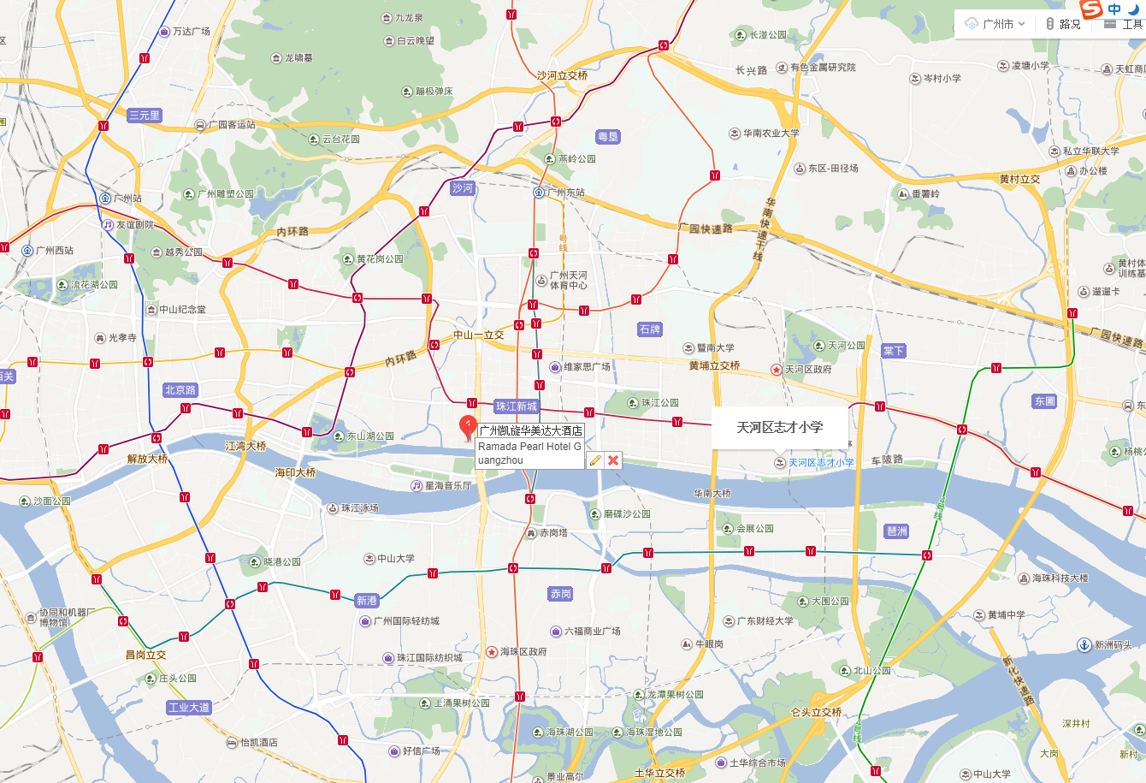

Tips：Baidu Maps App can be used to navigate your way around China.

